Монтажный лист: Методы в молекулярной биологии (Methods of molecular biology)
Module 1 – Molecular biology of viruses. Lecture 1.2 Virus-host interactions

АУДИО  Что говорим | ВИДЕО  Что показываем | Эффект
Welcome to the second lecture of the Module 1 – Molecular biology of viruses. Today we are going to speak about the virus-host interaction, and more detailly about the virus replication, lytic and lysogenic cycles  The co-existence of viruses with their hosts can be viewed as a molecular arms race between the virus and host elimination mechanisms. Continuous interactions between hosts and pathogens, during their co-evolution, have shaped the immune system and in turn viruses have manipulated host immune control mechanisms to facilitate their propagation. | Slide 1  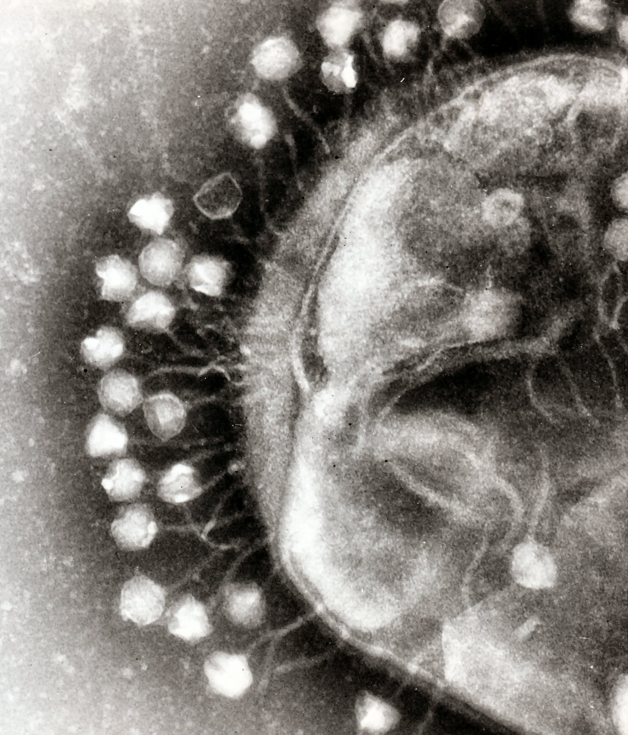 | Статика.  Весь слайд полностью как он есть
Today, viruses are so small and simple, they can’t even replicate on their own. Viruses carry only the essential genetic information they need to be able to slip inside a host cell and coax it into making new copies of the virus. The influenza virus, for instance, has a mere 14 protein-coding genes. Because viruses are usually so basic, many biologists didn’t think they could even be classified as a life form. | Slide 2  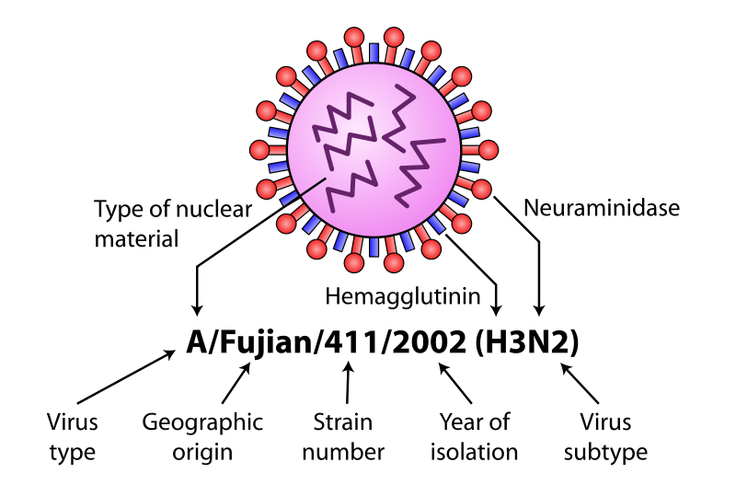 | Статика.  Весь слайд полностью как он есть
But just over a decade ago, our view of viruses began to shift. French scientists, who were examining a mystery microbe that looked like a bacterium, but was genetically quite different to bacteria, realized they discovered a giant virus. They named this bacteria look-alike the “mimicking microbe,” or “mimivirus”. And the mimivirus wasn’t only physically large. They showed that it carried more than 1,000 genes – a huge genome for a virus, just a few hundred genes smaller than some bacteria. Several giant viruses have been discovered since, with pandoraviruses packing around 1,100 genes. | Slide 3  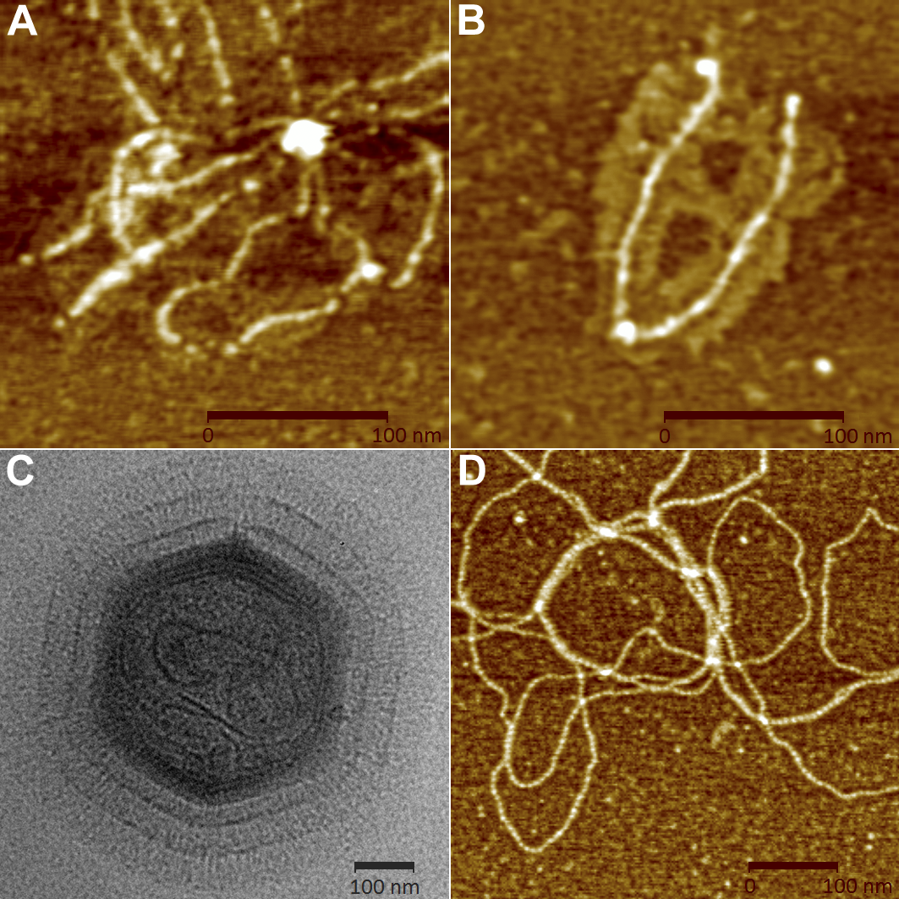 | Статика.  Весь слайд полностью как он есть
For the more abstract question of whether viruses qualify as life, Caetano-Anolles argues that if viruses are descended from living cells, they’re still alive now – but in a unique way: when viruses infect a cell, that reunion forms a complete living system. So many different types of viruses exist that nearly every living organism has its own set of viruses that try to infect its cells. Even the smallest and simplest of cells, prokaryotic bacteria, may be attacked by specific types of viruses. | Slide 4
To infect a host cell, the virus must first inject its own nucleic acid into the cell through the plasma membrane and (if present) the cell wall. The virus does so by either attaching to a receptor on the cell's surface or by simple mechanical force. The virus then releases its genetic material (either single- or double-stranded RNA or DNA) into the cell and cell becomes infected. The virus's nucleic acid uses the host cell's metabolic machinery to make large amounts of viral components. In the case of DNA viruses, the DNA transcribes itself into messenger RNA (mRNA) molecules that are then used to direct the cell's ribosomes. One of the first polypeptides to be translated destroys the host's DNA. In retroviruses (which inject an RNA strand), a unique enzyme called reverse transcriptase transcribes the viral RNA into DNA, which is then transcribed again into RNA. Once the viral DNA has taken control it induces the host cell's machinery to synthesize viral DNA, protein and starts multiplying. | Slide 5  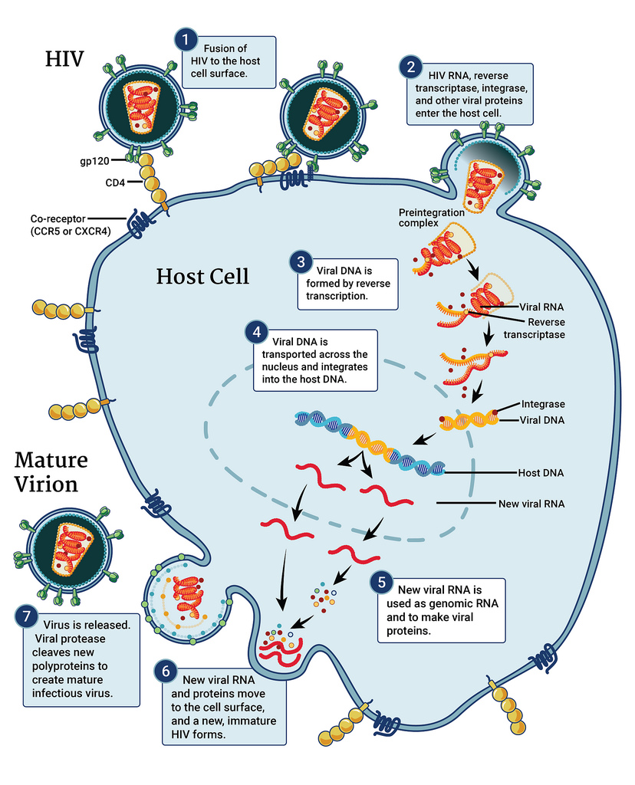 | Слайд с эффектами анимации
About 25 minutes after initial infection, approximately 200 new single individual particles of a virus, so called virions, are formed. Once enough virions have matured and accumulated, specialized viral proteins are used to dissolve the bacterial cell wall. The cell bursts (i.e. it undergoes lysis) due to high internal osmotic pressure (water pressure) that can no longer be constrained by the cell wall. This releases progeny virions into the surrounding environment, where they can go on to infect other cells and another lytic cycle begins. The phage that causes lysis of the host is called a lytic or virulent phage. | Slide 6  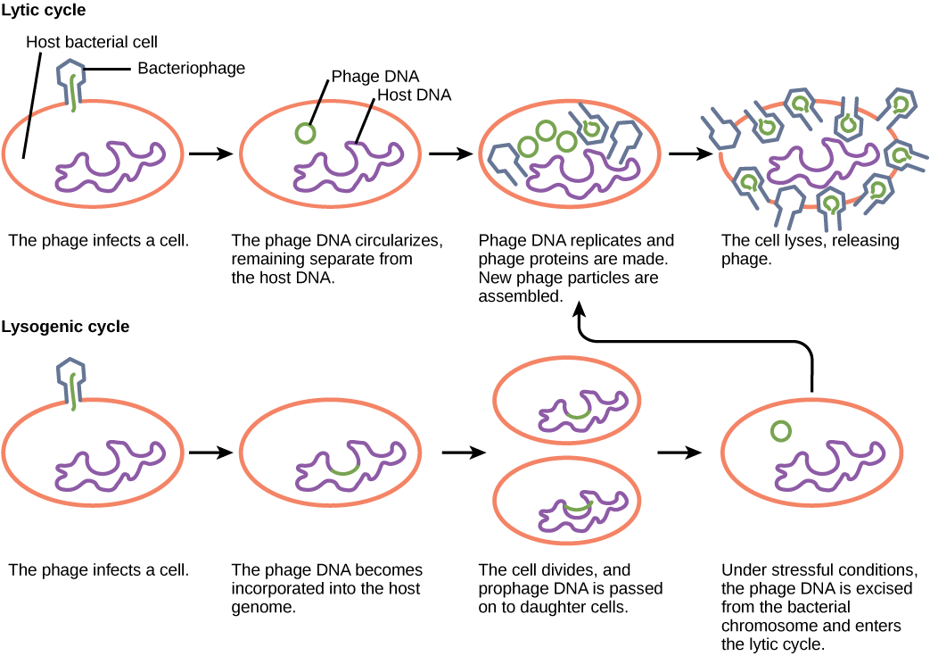 | Слайд с эффектами анимации
Some lytic phages undergo a phenomenon known as lysis inhibition, where completed phage progeny will not immediately lyse out of the cell if extracellular phage concentrations are high. | Slide 7
In contrast, the lysogenic cycle does not result in immediate lysis of the host cell. Those phages able to undergo lysogeny are known as temperate phages. Their viral genome will integrate with host DNA and replicate along with it fairly harmlessly, or may even become established as a plasmid. The virus remains dormant until host conditions deteriorate, perhaps due to depletion of nutrients; then, the endogenous phages (known as prophages) become active. At this point they initiate the reproductive cycle, resulting in lysis of the host cell. As the lysogenic cycle allows the host cell to continue to survive and reproduce, the virus is reproduced in all of the cell’s offspring. An example of a bacteriophage known to follow the lysogenic cycle and the lytic cycle is the phage lambda of E. coli. | Slide 8 | Слайд с эффектами анимации
Viruses that infect plant or animal cells may also undergo infections where they are not producing virions for long periods. An example is the animal herpes viruses, including herpes simplex viruses, which cause oral and genital herpes in humans. In a process called latency, these viruses can exist in nervous tissue for long periods of time without producing new virions, only to leave latency periodically and cause lesions in the skin where the virus replicates. Even though there are similarities between lysogeny and latency, the term lysogenic cycle is usually reserved to describe bacteriophages. | Slide 9  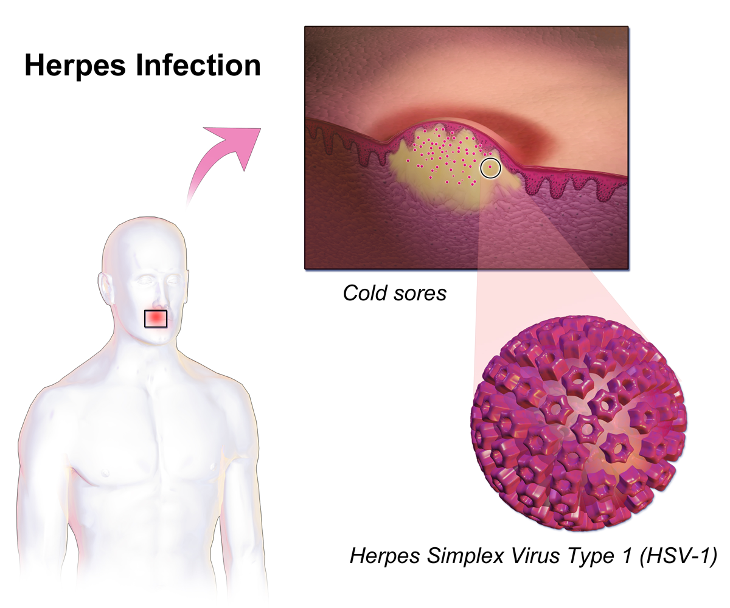 | Статика.  Весь слайд полностью как он есть
More insights you can get by completing the appropriate individual tasks, corresponding to this lecture. Please feel free to leave your questions and comments in the forum and we’ll be happy to answer them. Good luck and looking forward to seeing you soon, AiJ | Slide 10

